 | 12.1.18 Editors - Geometry Nodes Editor - Header - Add Menu - Curve - Write
Table of content
Detailed table of content 1
Add - Curve - Write 3
Set Curve Normal 3
Set Curve Radius 3
Set Curve Tilt 4
Set Handle Positions 4
Set Handle Type 5
Set Spline cyclic 6
Set Spline Resolution 7
Set Spline Type 7

Detailed table of content
Detailed table of content
Detailed table of content 1
Add - Curve - Write 3
Set Curve Normal 3
Input 3
Curve 3
Selection 3
Properties 3
Mode 3
Outputs 3
Curve 3
Set Curve Radius 3
Input 3
Geometry 3
Selection 4
Radius 4
Outputs 4
Geometry 4
Set Curve Tilt 4
Input 4
Geometry 4
Selection 4
Tilt 4
Outputs 4
Curve 4
Set Handle Positions 4
Input 4
Geometry 4
Selection 5
Position 5
Properties 5
Mode 5
Outputs 5
Geometry 5
Set Handle Type 5
Input 5
Curve 5
Selection 5
Properties 5
Mode 5
Handle Type 5
Free 5
Auto 6
Vector 6
Aligned 6
Output 6
Curve 6
Set Spline cyclic 6
Input 6
Geometry 6
Selection 6
Cyclic 6
Outputs 6
Geometry 6
Set Spline Resolution 7
Input 7
Geometry 7
Selection 7
Resolution 7
Outputs 7
Geometry 7
Set Spline Type 7
Input 7
Curve 7
Selection 7
Properties 7
Spline Type 7
Output 8
Curve 8

Add - Curve - Write
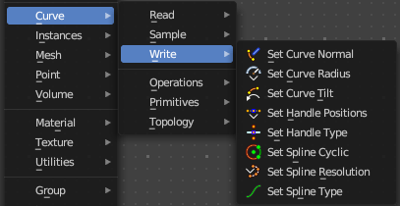
Here you find curve related nodes.

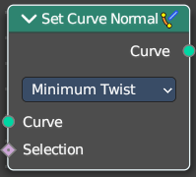
Set Curve Normal
Set the evaluation mode for curve normals.

Input

Curve
The input curve.

Selection
A selection of the input curve.

Properties

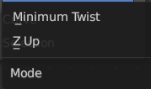
Mode
The evaluation mode for the curve normals.

Outputs

Curve
The curve output.

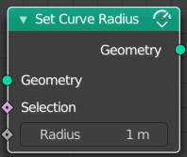
Set Curve Radius
Set the curve radius.

Input

Geometry
The input curve.

Selection
A selection of the input curve.

Radius
The radius to set.

Outputs

Geometry
Standard geometry output.

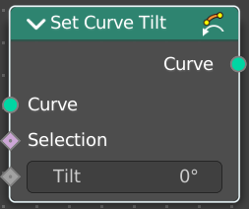
Set Curve Tilt
Controls the tilt angle at each curve control point.

Input

Geometry
The input curve.

Selection
Whether or not to change the value on each control point. True values mean the value will be changed, false values mean the value will remain the same.

Tilt
The tilt rotation.

Outputs

Curve
Standard geometry output.

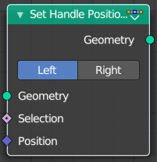
Set Handle Positions
Set the handle positions of bezier curves

Input

Geometry
The input curve.

Selection
A selection of the input curve.

Position
The position of the handle.

Properties

Mode
Left or right handles.

Outputs

Geometry
Standard geometry output.

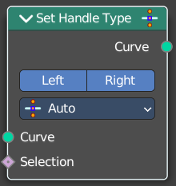
Set Handle Type
Sets a handle type for the curve points of a bezier curve. Handle types determines how the interpolation before and after the curve point happens.

Input

Curve
The input curve.

Selection
A selection of the input curve.

Properties

Mode
Left or right handles.

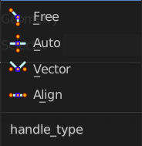
Handle Type
The different available handle types.

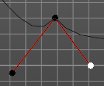
Free
The handles can be adjusted individually.

Auto
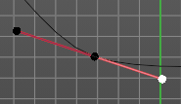
The left and the right handle will always point to each other. The length of the handles will start in equal size.

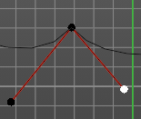
Vector
The handles can be adjusted individually.

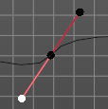
Aligned
The left and the right handle will always point to each other.

Output

Curve
Standard geometry output.

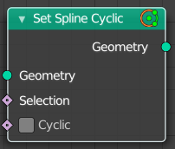
Set Spline cyclic
Sets the spline cyclic. Means looping.

Input

Geometry
The input curve.

Selection
A selection of the input curve.

Cyclic
Cyclic or not

Outputs

Geometry
Standard geometry output.

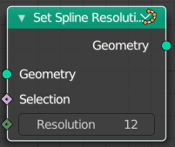
Set Spline Resolution
Sets the resolution of the spline. Means how many evaluated points should be generated on the curve for each control point.

Input

Geometry
The input curve.

Selection
A selection of the input curve.

Resolution
The resolution of the spline.

Outputs

Geometry
Standard geometry output.

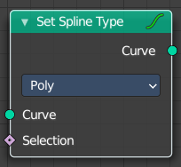
Set Spline Type
Change the curve spline type.

Input

Curve
The input curve.

Selection
A selection of the input curve.

Properties

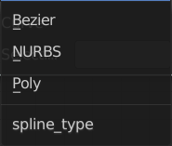
Spline Type
The spline type to set the curve to.
Note that when converting from a NURBS spline to a Bézier spline, at least six points are needed. When the number of points is not a multiple of three a full conversion is not possible and the spline has to be truncated.

Output

Curve
Standard geometry output.

